Professional Football Referees’ Association Inc.
profootballreferees@gmail.com
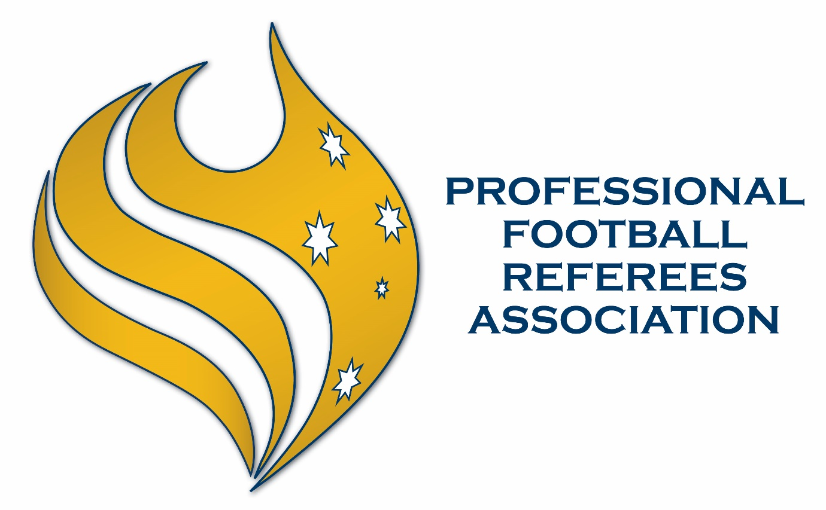
coDE OF CONDUCT

Table of Contents

1. Scope 3
2. Misconduct 3
2.1. General Behaviour 3
2.2. Discrimination 3
2.3. Bullying, Harassment and Victimisation 3
3. Reporting and Investigations 4
3.1. Reporting Breaches 4
3.2. Investigations 4
3.3. Confidentiality 4
4. Disciplinary Procedure and Sanctions 4

Scope

This Code of Conduct (Code) applies to the conduct and behaviour of all members of the Professional Football Referees’ Association Inc. (PFRA) (Member). Each Member agrees to be bound by the Code when becoming a Member of the PFRA.

Members of the PFRA are elite match officials officiating in the highest leagues in Australia and therefore must recognise their position as role models for other participants in football. Members must perform their duties, obligations and responsibilities with dignity and in an ethical manner at all times.

Members are bound by this Code in addition to any codes of conduct or statutes published by FIFA, AFC and FA from time to time.

Misconduct

General Behaviour

A Member must:

- Respect the rights and dignity of every person regardless of gender, race, ethnicity or sexual orientation;
- Promote a safe and inclusive environment, in which every person is protected and free from discrimination, harassment and abuse;
- Always ensure the safety and wellbeing of all participants;
- Maintain respectful and appropriate relationships with every person;
- Avoid situations that may lead to or call into question conflict of interest;
- At all times act as a role model for others, displaying high standards of good sporting behaviour;
- Never engage in inappropriate conduct including the use of offensive language whilst in an official capacity; and
- Adhere to the laws of the game and the principles of fair play, ensuring that the spirit of competition is respected by all players, coaches and officials.

Discrimination

A Member must not engage in any unlawful discriminatory behaviour towards a person on account of race, colour, religion, language, politics, national or ethnic origin, gender, transgender, gender identity and expression (including non-binary), intersex, sexual orientation, age, relationship status (including same sex couples), pregnancy or intellectual or physical impairment.

Bullying, Harassment and Victimisation

A Member must not engage in any conduct which amounts to bullying, harassment (including sexual harassment) or any unwelcome physical, verbal or sexual conduct which makes a person feel offended, humiliated and/or intimidated where that reaction is reasonable in the circumstances.

A Member must not victimise another person for reporting or indicating an intent to report a complaint.

A Member must not make any comment, statement or representation, including via any contribution to any form of media (including social media posts) that is disparaging or derogatory of another Member.

Reporting and Investigations

Reporting Breaches

Reports in relation to potential breaches of this Code are to be made to the President of the PFRA, unless the report is in relation to the President, in which case the report should be made to another member of the PFRA Executive Committee.

Investigations

The President (or the member of the Executive Committee that the report is made to) must take steps to investigate any reports made in accordance with clause 3.1, including by seeking information from other Members, relevant authorities and/or third parties. The President may also seek advice from external parties with the requisite experience in dealing with the relevant subject matter to ensure that the report is dealt with appropriately.

Confidentiality

Any report made in accordance with clause 3.1 (including the identity of a person making a report) will be kept confidential and only disclosed to other parties who have a need to know the information unless:

- otherwise required by law;
- otherwise permitted by this Code;
- the disclosure is required to fulfil the objectives of this Code; or
- the information is already in the public domain.

Disciplinary Procedure and Sanctions

Any Members found to have breached this Code will be dealt with in accordance with the disciplinary procedures outlined in the PFRA Constitution, in particular clauses 12 and 13.

Any substantiated breaches of this Code that are also breaches of any other codes of conduct published by FIFA, AFC or FA in force at the time must be reported by the PFRA to the appropriate body.

